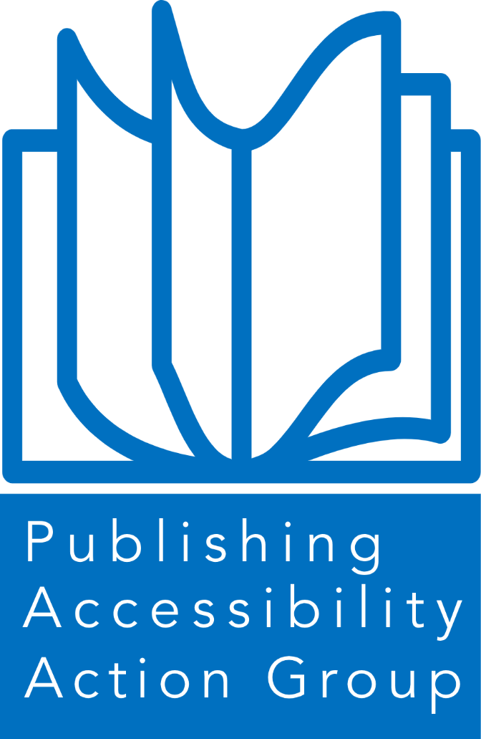
Publishing Accessibility Action group
  - ANNUAL REPORT 2025

Contents

- Introduction to the PAAG annual report 2025

- PAAG Working Group members

- Acknowledgements

- Accessible Publishing Charter
  - Charter signatories
  - Charter allies

- PAAG Community
  - Website
  - LinkedIn
  - Mailing list
  - Meetings

- Special theme: Past, Present, Future: A Survey of PAAG Charter members

Introduction from the PAAG chair

Welcome to the Publishing Accessibility Action Group Annual Report for 2025.
This has been a landmark year for accessibility in publishing. With the European Accessibility Act (EAA) coming into force in June 2025, accessibility has moved decisively from aspiration to obligation for many organisations. Across the industry, we have seen a significant shift: accessibility is no longer treated as a niche concern or a post-production fix, but increasingly as a core component of publishing strategy, workflows, and product quality. The work documented in this report reflects that turning point.
Throughout 2025, PAAG brought together publishers, vendors, and partners as they prepared for and responded to the EAA, sharing knowledge, practical guidance, and lived experience through our meetings, resources, and growing community. At the same time, we have been looking ahead. As we turn the corner into 2026, attention is already focused on the forthcoming updates to the Americans with Disabilities Act, including the revised ADA Title II requirements due to come into effect in April 2026. For global publishers and platforms, this evolving legislative landscape reinforces the need for consistent, scalable, and genuinely inclusive approaches to accessibility across regions and formats.
What has been particularly encouraging this year is the level of collaboration and openness across the publishing ecosystem. PAAG’s community has continued to grow, bringing together publishers of all sizes, technology providers, accessibility specialists, and advocates. The contributions captured in this report—from charter signatories and allies alike—demonstrate both the progress made and the honesty with which challenges are being addressed. From advances in accessible EPUB production and metadata, to improvements in platforms, workflows, training, and governance, the industry is clearly learning and maturing.
Yet compliance alone is not the end goal. Accessibility is ultimately about readers: ensuring that people with print disabilities can discover, access, and use content with the same choice, and timeliness as everyone else. As we move into 2026, PAAG remains committed to supporting the transition from compliance-driven activity to accessibility as business-as-usual—embedded from authoring through to delivery, and communicated clearly to those who rely on it.
I would like to thank the PAAG Working Group, our charter signatories and allies, our speakers, partners, and the wider PAAG community for their continued commitment, generosity, and expertise. The progress captured in this report is the result of collective effort, and it provides a strong foundation for the work still ahead.
Stacy Scott
Chair of the Publishing Accessibility Action Group and Head of Accessibility at Taylor & Francis Group

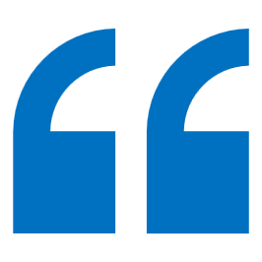
The objective of the PAAG is to embed accessible practices throughout the publishing ecosystem to ensure that all content and reading systems are designed to be inclusive and user-focused.

PAAG Working Group members 2025


The PAAG Working Group acts as a steering committee for PAAG. Led by Stacy Scott, Head of Accessibility at the Taylor & Francis Group, the working group gets together on a regular basis to discuss and implement initiatives. If you would like to join and contribute to the working group, please contact the chair via the PAAG LinkedIn Group or the PAAG mailing list.

In 2025, the PAAG working group members included:
- Stacy Scott, Taylor & Francis. Stacy is the Chair of the Publishing Accessibility Action Group
- Richard Orme, DAISY
- Simon Mellins, Simon Mellins Consulting
- Jenny Cundill, Quarto
- Leanne Dobson, Frontiers
- Ken Jones, Circular Software
- Huw Alexander, textBOX

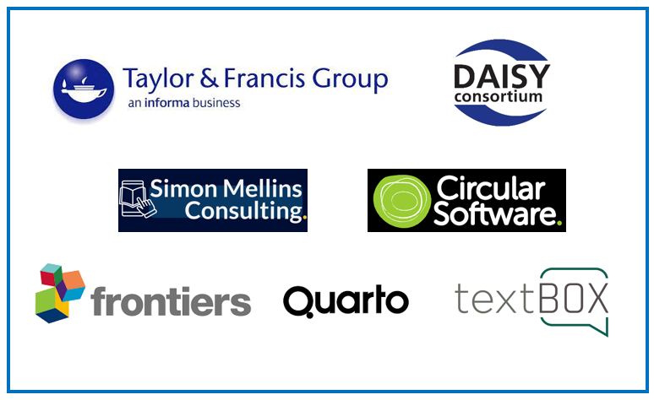

Acknowledgements

The Publishing Accessible Action Group are very grateful to the UK Association for Accessible Formats and textBOX for their generosity in supporting the PAAG website and mailing list in 2025.
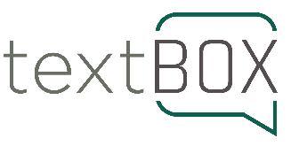
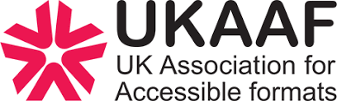

Accessible Publishing Charter
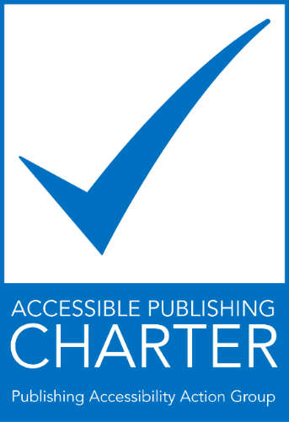
The Accessible Publishing Charter was launched in 2023 and encourages publishers and organisations to sign up to the charter and support the development of accessible publishing across the industry. The Charter can be signed by publishers and publishing allies (vendors in the wider publishing industry).
The growing availability of ebooks and other digital publications provides an unprecedented opportunity for persons with print disabilities to enjoy access to mainstream content at the same time, in the same format and at the same price as other readers. UK publishers and authors are eager to explore and develop the advantages that ebooks offer and, in so doing, reach more readers. Ensuring that ebooks are fully accessible, however, will only happen if publishers, authors, developers, platforms, and other stakeholders focus on this issue at a practical level.
Our objective is to make our content accessible to all and to aid others in this endeavour.
The signatories to the Accessible Publishing Charter endorse and promote the following 10 goals:
- Raising awareness among, and providing training for, relevant staff.
- Nominating a company “accessibility champion” who can bring together key stakeholders to discuss potential accessibility improvements and act as a liaison for all accessibility information.
- Publishing our accessibility policy on our website, including our commitment to this charter.
- Designating and publicising a point of contact in our organisation to assist persons with disabilities to access alternate formats of our content.
- Partnering with national and international organisations that provide support for the availability of publications in accessible formats.
- Incorporating appropriate accessibility features within our digital publications and platforms, according to the web content accessibility guidelines and other appropriate accessibility standards.
- Advocating for accessibility standards and collaboration throughout the publishing supply chain from author to reader.
- Utilising the accessibility metadata opportunities available to aid with the discovery of accessible content.
- Testing and validating content to ensure it is usable by people with print disabilities. Ideally this would include testing by persons with lived experience.
- Monitoring our progress in this area and regularly assessing the accessibility of our digital publications and platforms.


Charter signatories

27 publishers have signed up to the PAAG Accessible Publishing Charter (an increase of 50% in 2025):

- Arcturus Publishing
- Bloomsbury
- Boldwood Books
- Cambridge University Press & Assessment
- Edward Elgar Publishing Ltd
- Elsevier
- Facet Publishing
- Hachette UK
- HarperCollins Publishers
- Kogan Page
- Leamington Books
- Macmillan Education
- Macmillan Learning
- McGraw Hill
- New Island
- Pan Macmillan
- Penguin Random House
- Pottermore Publishing
- Princeton University Press
- The Royal Society Publishing
- Sage
- Springer Nature
- Taylor & Francis
- UCL Press
- Ulverscroft
- University of London Press
- Zanichelli Editore

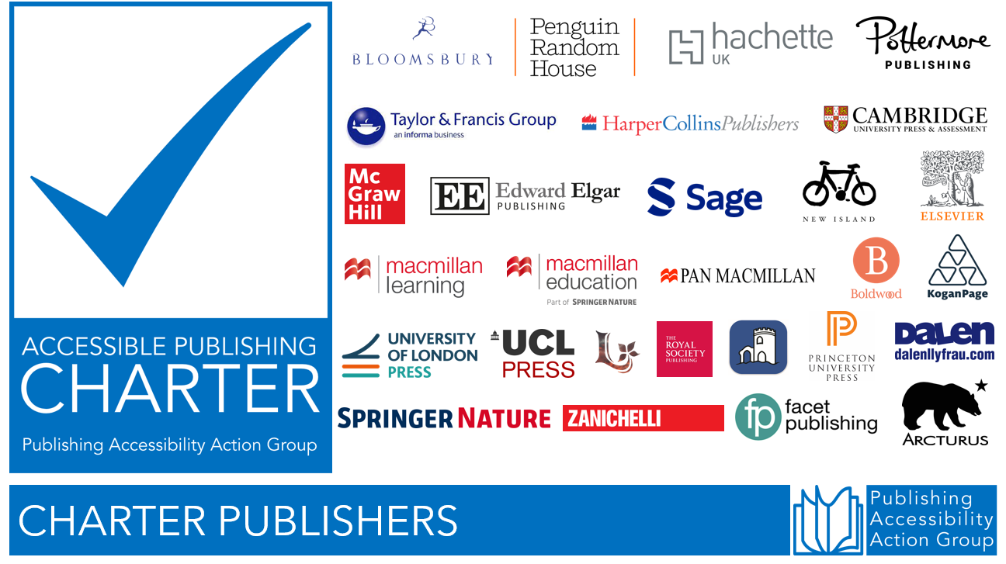

Charter allies

55 organisations have signed up to the PAAG Accessible Publishing Charter as allies (an increase of 28%).
- ALISS
- Amnet
- AulaSIC
- bookcareers
- BookMachine
- BooksoniX
- Browns Books
- Calibre Audio
- Cenfor International
- Circular Software
- Clarivate
- codemantra
- Colibrio Software AB
- Connect Design Solutions
- Consonance
- Continual Engine
- Copyright Licensing Agency (CLA)
- CPI Group UK
- DAISY Consortium
- Dalen
- EDItEUR
- eLaHub
- Flexedo
- Fondazione LIA
- Glassboxx
- Haremi
- Have a Book
- iAccessDigital
- Impelsys Ltd
- Independent Publishers Guild (IPG)
- Ingram Content Group
- Inspired Search & Selection Ltd
- Integra Software Services
- ISI
- Jellybooks
- Just Content
- Lapiz Digital Services
- Laura Brady, Accessible Publishing Consultant
- Leamington Books
- Lithuanian Audiosensory Library
- Lumina Datamatics
- Publishing Ireland
- Publishing Scotland
- Refreshing Publishing
- Royal National Institute of Blind People (RNIB)
- RNIB Bookshare
- Share the Vision
- Simon Mellins Consulting Ltd
- Six Red Marbles UK
- textBOX
- Typeflow
- UK Association for Accessible Formats (UKAAF)
- VitalSource Technologies
- Westchester Education UK and International
- Westchester Publishing Services UK

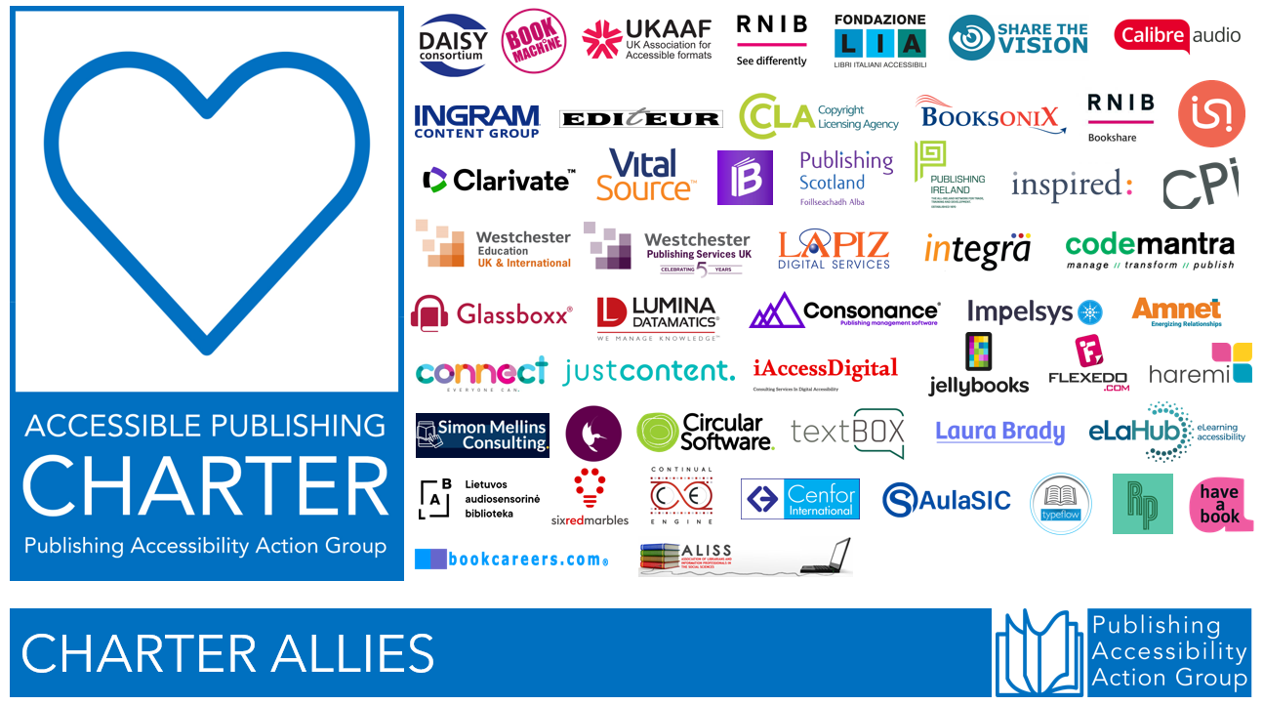

The PAAG Community

The PAAG community has continued to develop in 2025 with an expansion of our website resources pages to reflect the advent of the European Accessibility Act, the LinkedIn group attracting 641 members, bi-monthly meetings with guest speakers, a mailing list forum with 234 members, and attendance at a range of industry events.

PAAG Website
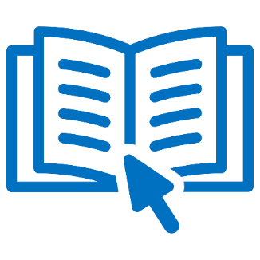
The PAAG website provides a wide range of resources for publishers seeking to implement accessible publishing programmes.
The website explores the business case for accessible publishing and provides the answers to frequently asked questions about accessible publishing. The resources pages cover a wide range of topics including:

- Alt text: creating image descriptions for all types of content.
- Assistive technology: including screen readers.
- Formats: including, EPUB, PDF, and Microsoft products.
- Metadata: information about metadata including ONIX and Thema.
- Accessibility organisations and advocates: a list of national and international organisations working in the accessibility field.
- Legal regulations and guidelines: including WCAG, PSBAR, Section 508, Marrakesh, and a comprehensive list of articles and resources about the European Accessibility Act (EAA).
- Testing and certification: including the Accessible Books Consortium, Global Accessible Accreditation from Benetech, Fondazione LIA, and the ASPIRE accessibility statement review service.
- Accessibility tools and solutions: guides for accessibility tests and useful tools to help with the process including DAISY Ace.
- Training and learning: a selection of resources for training purposes and learning more about accessible publishing including webinars and courses.

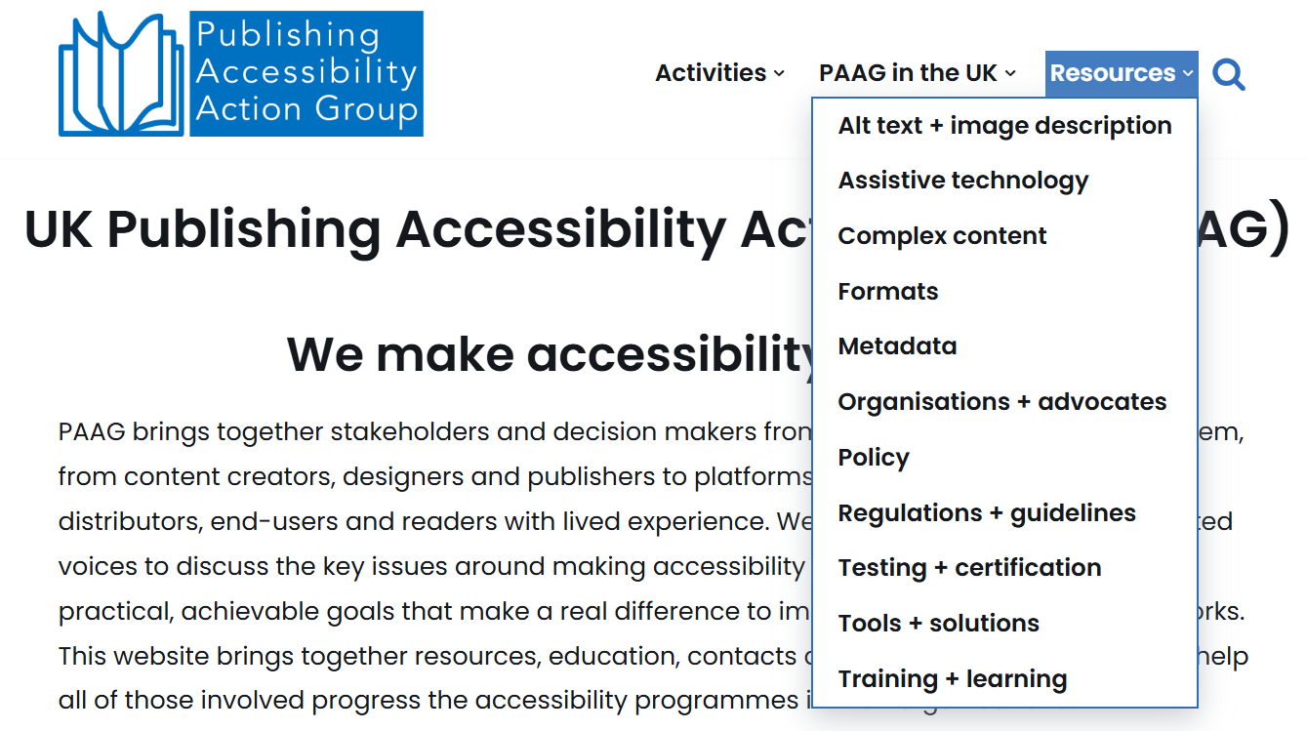
The PAAG website has been viewed by over 10,000 visitors from 94 countries in 2025, highlighting the high level of interest in developing accessible publishing programmes across the world.
58% of visitors were from Europe, 26% from North America, 12% from Asia. After the UK, PAAG website visitors were from US, Germany, India, Ireland, Australia, Netherlands, China, and Canada.

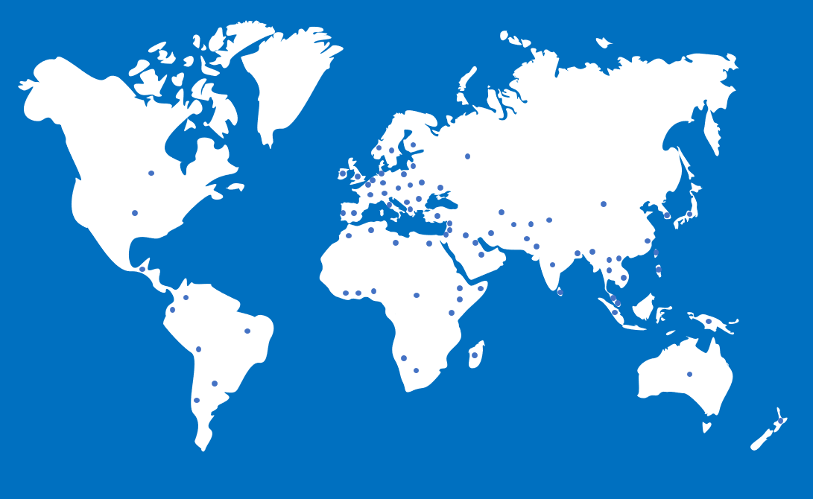

The PAAG website was kindly supported by UKAAF in 2025.

PAAG LinkedIn Group


The PAAG LinkedIn group was launched in early 2023 and now welcomes 641 members from around the world (an annual increase of 38% in 2025). The group acts as a forum for sharing news and information, and for discussing and implementing accessible publishing. The group contains a wide variety of members from across the publishing community, including an international range of publishers, ebook platforms, technology vendors, academic institutions, and accessibility advocates.
The LinkedIn group welcomes anyone interested in accessible publishing to join the community.

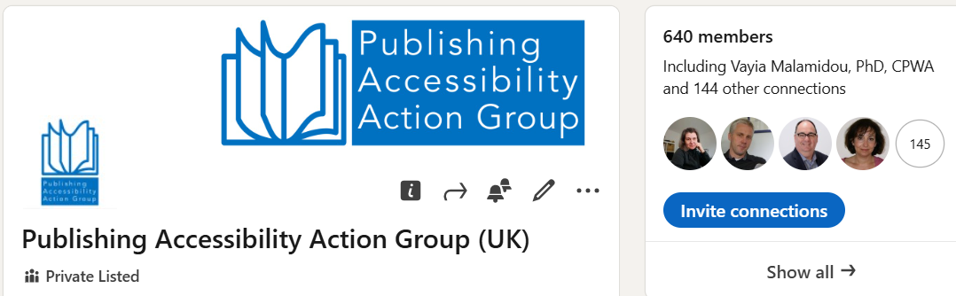

PAAG Mailing List
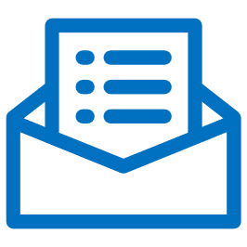
The PAAG mailing list launched in 2025 and now has a bustling membership of 234 participants. The list acts as a forum for member questions and the sharing of ideas and advice around accessible publishing.
Topics covered in the forum this year ranged from the macro to the micro:

- Transcripts and versions of record
- Accessible ePub for journal articles
- Taxonomy of images for alt text/long descriptions
- UK audio book vendors
- PowerPoint accessibility
- Language shifts, media overlay, footnotes
- Metadata query - backlist
- Alt-Text for MathML content
- Product content type metadata availability
- programming codes as figures that are not images
- Accessible Maps
- accessModeSufficient metadata calculator
- Alt text in PDFs
- Sections with no headings in InDesign
- What EPUB reading apps do you test against?
- New research on (in)accessibility of life science websites
- ADA and Submissions Platforms
- Non-accessible ebooks - remove from the market or mark as not accessible?
- Apple ingestion error due to language in OPF file
- Handling frequent marginalia in an accessible EPUB
- Mathematical content
- The Websites and Software Applications Accessibility Act of 2025
- WCAG AA vs AAA Compliance for EPUBs
- Long maths equations and display in ePUB format
- Accessibility metadata display guide for digital publications 2.0 is released!
- Tactile images
- Author or publisher responsible for accessible documents?
- Distributing accessible ePubs
- Accessibility of Altmetrics and Citations/Dimensions badges
- <dl> <dt> and <dd> tag query
- Accessible DOIs
- Colour contrast/use of colour ebook compliance failures
- Accessible Fixed Layout
- Response to updated ADA Title II guidelines
- Accessibility metadata for ebooks with media overlays
- Guidance on ePub Accessibility Whitepaper
- RNIB Bookshare accessibility checks
- Accessibility certification
- Super and subscript question
- Captions/subtitles for media in another language
- MathML and NVDA
- Interactive Exercises
- Updated techniques for accessible PDF
- Emojis

Anyone interested in accessible publishing can sign up to the mailing list via the PAAG website.

PAAG Meetings

5 PAAG meetings have taken place in 2025. The brief agendas from each meeting are listed below and outline the range of diverse topics addressed by the group this year.

27 February 2025
- What’s new in the world of accessible publishing: DAISY ACE, Thorium, and InDesign.
- Demo of new RNIB Bookshare features.
- Update from the Accessible Music Publishing Action Group (AMPAG).
24 April 2025
- EAA readiness exchange.
- Tactile graphics or objects in digital publications.
- Updates from LBF and CSUN.
- Member and charter signatory update.
24 July 2025
- Discussion with guest speaker Susi Miller, founder of eLaHub and award-winning author of Designing Accessible Learning Content.
- Highlights from the LIA Foundation European accessibility summer school.
- National Upskills Digital accessibility specialist L4 apprenticeship programme.
- The PAAG Constitution.
25 September 2025
- Discussion on the current state of EAA implementation.
- Accessibility of journal content: challenges and solutions.
- Open Book Futures project: accessibility guidance for small presses.
27 November 2025
- DAISY principles for image descriptions in digital publications.
- Pocket Potters: No-Code Accessibility for Fixed-Layout EPUB for Pottermore.
- Affinity: a new, free way to make professional accessible EPUBs.
- DAISY toolbox explained: EPUBtest, Ace, SMART, and Accessible Publishing Knowledge Base.

Special theme: Past, Present, Future

Introduction

In this year’s Special Theme, PAAG Charter members reveal the successes and challenges they encountered in 2025 and their plans for 2026. We asked the following 2 questions:

- What are your accessibility highlights of the past 12 months?
- What are you working towards in terms of accessibility in the coming year?

The following pages include the responses from PAAG charter members and provide insights into their achievements over the past 12 months and the future accessibility plans of key players in the publishing industry. Explore the responses from Taylor & Francis, Codemantra, Simon Mellins, Laura Brady, Have a Book, Jellybooks, Elsevier, Consonance, Fondazione LIA, Sage, Kogan Page, Impelsys, and textBOX.

TAYLOR & FRANCIS



Increased eBook catalogue with 100% alt text from 10,849 titles in January 2025 to 17,905 in November 2025 (65% growth).

What are your accessibility highlights of the past 12 months?

Ebooks
- Integrated AI-generated alt text into all workflows (front-end and backlist), with human review, reducing costs and improving accessibility.
- Ensured full accessibility compliance for all new eBook conversions since June 2025, meeting European Accessibility Act (EAA) requirements.
- Increased eBook catalogue with 100% alt text from 10,849 titles in January 2025 to 17,905 in November 2025 (65% growth).
- Collaborated with the Innovation Team to develop internal AI tools for alt text, MathML, and accessible tables.
- 200 Fixed Layout EPUBs converted to EPUB3.
- 2,850 new eBook conversions in 2025.
- Published an average of 590 fully accessible eBooks per month.
- Retained Global Certified Accessible accreditation.
- Updated ONIX accessibility metadata to include certified credentials and hazard warnings.
- Tested new processes to inject accessibility metadata directly into EPUB content.
Customer support, accessible Format Request Service
- Actioned 812 file requests via the Visually Impaired Persons (VIP) inbox.
- Expanded request service to include accessible ancillary support materials (e.g., PPTs, score cards, test banks).
- Expanded requests service to include transcripts and video remediation requests for journals.
- Improved the user experience for requesting accessible journal related materials.
- Created templates and guidance for Customer Service teams to ensure customers are supported quickly and efficiently.
Journals
- Enhanced workflows for descriptive transcripts for video abstracts (200 per year).
- Worked on ensuring embedded video accessibility and better functionality and discovery
- Began work on enhancing accessibility of our EPUB outputs.
Platforms and compliance
- Fixed critical accessibility issues on Routledge collections and Taylor & Francis eBooks platforms.
- Onboarded 53 sites to our automated accessibility audit tool, Siteimprove, totalling 59 digital products (40% of T&F's portfolio).
- Conducted 97 manual accessibility audits covering 40 products/services.
- Completed Accessibility Conformance Reports for 22 websites, and updated 23 Accessibility Statements.
Partnerships and stakeholder engagement
- Contributed to and attended industry working group sessions and subscribed to updates, to continue to influence standards and remain knowledgeable of the changing legal landscape.
- Became an organisational member of the International Association of Accessibility Professionals (IAAP).
- Continued partnerships with RNIB Bookshare and Benetech’s Bookshare platform, ensuring 95% of the eBook catalogue is globally available in accessible formats.
- Shared over 25 free accessibility events and launched a Bitesize Accessibility series with training videos and resources.
- Produced the EAA and then ADA Countdown Series and insights throughout 2025 and shared with colleagues to support upskilling across the business.
- Presented at 25+ webinars and conferences, including London Book Fair and DAISY webinars.
- Continued membership of multiple accessibility working groups, including PAAG, UKAAF, DAISY Consortium forums, and AMPAG, contributing to evolving standards and legislative discussions.

What are you working towards in terms of accessibility in the coming year?

- Continue our work to ensure more platforms and sites are fully accessible and compliant - working to very detailed roadmaps, informed by strict manual and automated audits.
- Continue enhancement of accessibility of our EPUB outputs for new journal content.
- Automated AI captions for all videos on Taylor & Francis Online (journal site) starting December 2025.
- AI-generated alt text for journal images to roll out in March 2026.
- Continue to work with Benetech to retain Global Certified Accessible accreditation.
- Increase the scope of accessible ancillary and support materials (e.g. PPTs, test banks, quizzes, etc). These materials are part of a larger Ancillary Project where archiving and content remediation workflows will be in development in 2026.
- Develop further solutions to include video transcripts, captioning and audio description across our platforms.

CODEMANTRA

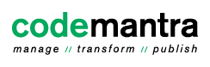
Our experience has been that publishers have grasped compliance with the EAA and forthcoming ADA Title II opportunities not just requirements.

What are your accessibility highlights of the past 12 months?

Generally, the growing levels of engagement in accessibility remediation, which the growing numbers of PAAG members illustrate, and PAAG’s position as such a rich resource of expertise and knowledge to support digital accessibility efforts. The industry-wide focus on quality has been refreshing. We have had experience (outside of publishing) of a “good enough” approach to remediation, but our experience has been that publishers have grasped compliance with the EAA and forthcoming ADA Title II opportunities not just requirements. For Codemantra specifically, 2025 has been the realisation and impact of a lot of hard work during 2024 with our alt text writers collaborating with our prompt engineering team to produce a truly contextualised, AI-generated alt text output, which is now being used by a wide range of publishers, large and small, from trade illustrated to complex STEM. The same teams have produced automated image assessment tools and video captioning and description tools which we expect to really have an impact in 2026.

What are you working towards in terms of accessibility in the coming year?

The arrival of ADA Title II has required Codemantra to take the tools described above and ensure they are scalable to handle significant volumes of titles and images - and ensuring that scalability and further refinements to the sophistication of our alt ext tools will be a focus for 2026. We will also be focusing on the role our asset and metadata management platform collectionPoint can play going forward in the mix of accessibility services and solutions we offer both for file formats - especially PDFs - and metadata management. The management, updating and enhancement of metadata will be a focus for the US higher education sector as they prepare to meet Title II regulations and there is already a lot of discussion about what that metadata should look like and how to deliver and validate it, and that conversation is one we will actively participate in.

SIMON MELLINS CONSULTING

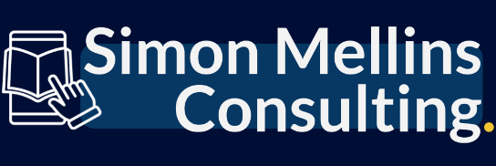

I've been privileged to work with a wide range of publishers and other organisations around the world to help them re-tool and reorganise their workflows to become compliant with the EAA.

What are your accessibility highlights of the past 12 months?

With the enforcement of the EAA finally arriving this June, it's been a dramatic year where lots of organisations have kicked into gear when it comes to getting their processes - and ultimately their content - in line for accessibility. I've been privileged to work with a wide range of publishers and other organisations around the world, across publishing sectors and organisational scales, to help them re-tool and reorganise their workflows to become compliant with the act and turn the page for print-disabled readers. I've also worked with some innovative vendors doing amazing work that will empower publishers to make better changes, faster and more responsively in the near future.

What are you working towards in terms of accessibility in the coming year?

As well as continuing to help publishers come to terms with the EAA, ADA and other global accessibility legislation, this year I'm focusing a lot on training publishing teams on core ebook skills including accessibility, and continuing my work with developers and nonprofits on tools to assist the industry. This year will be a real litmus test for the industry to see if the interest in accessibility can be sustained now that the EAA deadline has passed - let's hope that with fantastic organisations like PAAG to facilitate the conversation, and knowledgeable professionals at publishers advocating for our cause, that this can truly be the year of 'accessibility as business-as-usual'.

LAURA BRADY

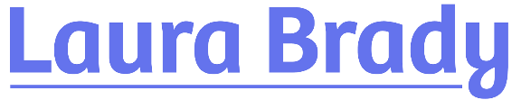

It is also absolutely remarkable to me that accessibility metadata is now available on so many vendor websites — even Amazon! This, in my opinion, is the clearest marker of progress in this work.

What are your accessibility highlights of the past 12 months?

The number of webinars, white papers, workshops, etc. around accessibility was delightful to witness. If people weren't aware of the EAA and accessibility work, it was out of deliberate ignorance as you couldn't miss it.
It is also absolutely remarkable to me that accessibility metadata is now available on so many vendor websites — even Amazon! This, in my opinion, is the clearest marker of progress in this work.
Finally, the work on the InDesign-to-EPUB export is really bearing fruit. While it is slow and a little bit painful, the quality of the EPUB export is vastly improved over a year ago. The expert working group is persistent and dogged in pushing for change. This might be the single most impactful work I've ever done as publishers around the world are "accidentally" making better EPUBs because of their reliance on InDesign and the changes we have effected to ID's EPUB export.

What are you working towards in terms of accessibility in the coming year?

- Continuing the InDesign work.
- Continuing to offer training, talking, guiding, consulting.
- Reining in AI to serve accessibility needs rather than to co-opt creativity.

SIMON MELLINS CONSULTING

I've been privileged to work with a wide range of publishers and other organisations around the world…to help them re-tool and reorganise their workflows to become compliant with the EAA.

What are your accessibility highlights of the past 12 months?

With the enforcement of the EAA finally arriving this June, it's been a dramatic year where lots of organisations have kicked into gear when it comes to getting their processes - and ultimately their content - in line for accessibility. I've been privileged to work with a wide range of publishers and other organisations around the world, across publishing sectors and organisational scales, to help them re-tool and reorganise their workflows to become compliant with the act and turn the page for print-disabled readers. I've also worked with some innovative vendors doing amazing work that will empower publishers to make better changes, faster and more responsively in the near future.

What are you working towards in terms of accessibility in the coming year?

As well as continuing to help publishers come to terms with the EAA, ADA and other global accessibility legislation, this year I'm focusing a lot on training publishing teams on core ebook skills including accessibility, and continuing my work with developers and nonprofits on tools to assist the industry. This year will be a real litmus test for the industry to see if the interest in accessibility can be sustained now that the EAA deadline has passed - let's hope that with fantastic organisations like PAAG to facilitate the conversation, and knowledgeable professionals at publishers advocating for our cause, that this can truly be the year of 'accessibility as business-as-usual'.

HAVE A BOOK
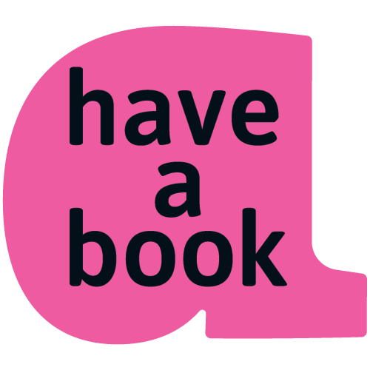

We published our own e-book, created in cooperation with the Polish Foundation for the Blind and Visually Impaired, Accessible Ebooks: A Practical Guide for Publishers.

What are your accessibility highlights of the past 12 months?

International events (Speakers)
- 16 May 2025 – Warsaw International Book Fair Panel discussion: “Accessibility in Publishing Practice”, organised by the Accessibility Team of the Polish Book Chamber (PIK).
- 23 October 2025 – 28th International Book Fair in Krakow Presentation: “Accessible Digital Publications – How We Do It and Why Exactly This Way”.
Publications Promoting Accessibility
- Published our own e-book, created in cooperation with the Polish Foundation for the Blind and Visually Impaired “Trakt”: “Accessible Ebook. Practical Guide for Publishers”, available for free on our website: https://www.haveabook.eu/accessibilty
- Published 15 articles in cooperation with the Polish Foundation for the Blind and Visually Impaired “Trakt” on our blog under the category accessibility, sharing best practices, alt-text guidance, and accessibility insights. https://www.haveabook.eu/blog
- Produced the accessible digital edition of “Głos niewidomych czytelników” (“The Voice of Blind Readers”), the final report of the Polish Foundation for the Blind and Visually Impaired “Trakt” on digital reading by blind users.
Development of Tools and Formats Supporting Accessibility
- Created the Alt Text Integrator, our SaaS tool that generates image descriptions and embeds them directly into EPUB, offering the fastest way to enrich existing e-books with alt texts and prepare them for accessibility requirements: https://www.haveabook.eu/alt-text-integrator
- Developed our EPUB Flex format, which preserves the original fixed-layout design while adding accessibility features such as correct reading order, semantic headings, tagged tables and other, and used it to produce the accessible digital edition of Klimatyczne ABC. The book’s complex design – including charts, diagrams, block quotes and notes – is fully adapted for screen readers without losing its original look and feel.

What are you working towards in terms of accessibility in the coming year?

Have a Book planned accessibility activities in 2026:
- Have a Book will produce the second edition of Books without Barriers: A Practical Guide to Inclusive Publishing, by Julie Ganner, Agata Mrva-Montoya, Maryanne Park, and Kayt Duncan, and publish a Polish-language translation for the domestic market , scheduled for March 2026.
- Maintaining regular blog posts and expanding Accessibility category content.
- Further enhancing the Alt Text Integrator with new advanced features, including editing options and long-description support.
- Developing the conversion of mathematical equations from different source files into accessible epubs.
- Expanding our presence at industry events and book fairs with new presentations on accessibility.

JELLYBOOKS



Jellybooks launched a major accessibility upgrade to its DISCOVERY platform providing accessible, online book samples and previews to online book retailers.

What are your accessibility highlights of the past 12 months?

In 2025, Jellybooks launched a major accessibility upgrade to its DISCOVERY platform providing accessible, online book samples and previews to online book retailers including Blackwell’s (UK), Dubray Books (Ireland), Eason (Ireland), ARK Bokhandel (Norway), Adlibris (Sweden), Exclusive Books (South Africa) and many independent bookshops in the UK, Ireland, France, Spain, and beyond. The new version of the Jellybooks Cloud Reader powering the click & read experience features a redesigned user interface, dedicated themes for dyslexic, low vision, and blind readers, as well as support for publisher’s accessibility statement, text-to-speech support and much more. A summary of the approach taken can be found in this LinkedIn article: https://www.linkedin.com/pulse/creating-accessible-book-sampling-experience-all-andrew-rhomberg-gnzse/

What are you working towards in terms of accessibility in the coming year?

In 2026, Jellybooks will extend the functionality of its DISCOVERY platform to provide accessible click & read access to open access (OA) titles (full length, not just 10% samples) as well as accessible, ePub-based review copies for bookshops and retailers offering an accessible, secure, cloud-based alternative to PDF-based inspection and review copies (for more information email us at accessibility@jellybooks.com).

ELSEVIER

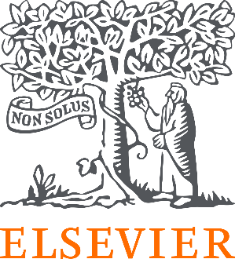

Rolled out alt-text and accessibility metadata to all our frontlist eBooks sold in Europe, along with the associated videos and ancillary materials.

What are your accessibility highlights of the past 12 months?

- Rolled out alt-text and accessibility metadata to all our frontlist eBooks sold in Europe, along with the associated videos and ancillary materials.
- Remediated over 8,500 backlist books and set up an ‘on request’ service for the remainder.
- Implemented PDF tagging for our frontlist books and journals.
- Brought at least 50 Elsevier apps and eBook formats into EAA readiness by the June 2025 deadline.
- Conducted validation of our new accessibility features with end users with lived experience and implanted their recommendations.
- Launched a public repository of 90 VPATs/ACRs and product accessibility statements.
- Launched a formal / measurable process for integrating accessibility into UX design and software testing phases.
- Continued to publish important accessibility and disability research in new books such as International Review Research in Developmental Disabilities, Climate Change and Disability. And in several of our journals including International Journal of Human-Computer Studies and Computer Standards & Interfaces.
- Recertified our Benetech Globally Certified Accessible for Elsevier ePUB books.
- Expanded our accessibility training with new learning paths and more capacity.
- Customized accessibility training for our Sales, Legal, and Customer support teams.

What are you working towards in terms of accessibility in the coming year?

- Developing our capabilities for journals, to roll out in 2026.
- Developing accessibility best practices and guidelines around our AI and chat interfaces, and also for our society publishing partners.
- Wider adoption of WCAG 2.2 standards and policy updates.
- Expanding our user research program around people with disabilities.
- Working towards a fully accessible author submission experience.

CONSONANCE



We invested in the foundations of long-term accessibility by strengthening our in-house expertise through accessibility training accredited by the IAAP.

What are your accessibility highlights of the past 12 months?
Over the past year, we’ve focused on making Consonance easier and more inclusive for everyone to use, and we’re proud of the progress we’ve made. We strengthened screen-reader support, improved keyboard-only navigation, and introduced dark mode and the Atkinson Hyperlegible typeface to enhance readability and reduce eye strain.
We also invested in the foundations of long-term accessibility by strengthening our in-house expertise through accessibility training accredited by the International Association of Accessibility Professionals (IAAP), adding automated Playwright accessibility tests to our development workflow, and expanding manual testing with feedback from people with lived experience of disability.
We continue to help our clients get the most out of their ebooks by automatically pulling accessibility metadata from their EPUBs and generating accessible tables of contents to include in their ONIX feeds. Our clients are still responsible for producing accessible files, but once that work is done, we make sure the accessibility information gets in front of the right people.
Across the company, we set WCAG 2.1 Level AA as our baseline and continued moving towards Level AAA where feasible. We also updated our marketing website, user documentation, and training materials to meet WCAG standards, ensuring a more consistent and accessible experience across both our product and our public-facing content.
What are you working towards in terms of accessibility in the coming year?
In the year ahead, we want accessibility to feel even more embedded in how Consonance is designed, built and used. We’ll be working more closely with publishers and accessibility groups, continuing to improve keyboard and screen-reader experiences, and raising our standards as we move towards higher levels of WCAG compliance across our product and website.

FONDAZIONE LIA

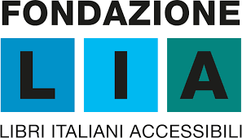

Accessibility is increasingly recognised as a strategic, structural element of publishing, rather than a corrective action added at the end of the production process.

What are your accessibility highlights of the past 12 months?

One of the most significant highlights has been witnessing a clear shift in mindset across the publishing industry: accessibility is increasingly recognised as a strategic, structural element of publishing, rather than a corrective action added at the end of the production process. More and more publishers are integrating accessibility from the earliest editorial and design stages, signalling a real cultural change.
Another important highlight is the growth of cooperative projects, such as APACE, where publishers, libraries for the blind, and accessibility experts work together rather than in parallel towards shared goals. This collaborative approach has strengthened trust across the value chain and improved both the quality and scalability of accessible publishing practices.
Finally, a major milestone has been the ability to make accessibility metadata of the thousands of Italian accessible eBooks created by LIA available for display on major online store and to make them visible on the LIA Catalogue following the metadata display guidelines. Making accessibility features visible and interoperable has been essential to ensuring that accessible content can actually be found, identified, and used by readers who need it.

What are you working towards in terms of accessibility in the coming year?

In the coming year, a key focus will be expanding work with educational publishers, supporting them in integrating accessibility into complex learning materials and workflows. The most important goal will be strengthening communication towards readers. The publishing industry has made substantial progress over the past months, but this effort needs to be more clearly communicated so that readers with print disabilities can understand what has changed, what is now available, and how to recognise accessible publications. Making accessibility visible, understandable, and trusted by end users will be a central goal moving forward.

SAGE



Our main accessibility highlight of the past 12 months was achieving Benetech’s GCA compliance.

What are your accessibility highlights of the past 12 months?

At Sage, our main accessibility highlight of the past 12 months was achieving Benetech’s GCA compliance.
We also took part in a range of conferences during the year, including presentations at the Electronic Resources & Libraries conference in Austin, Texas with librarians (Let’s Talk Accessibility: Collaborating for Change) and Accessing Higher Ground in Denver, Colorado (Accessibility Experiences of Developing Sage Campus)

What are you working towards in terms of accessibility in the coming year?

What we are working toward in terms of accessibility in the coming year are initiatives to further the accessibility of Sage Journals content in light of the upcoming updated Title II ADA deadline.

KOGAN PAGE

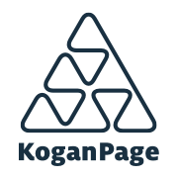

Our born accessible ebooks continue to contain all main accessibility features, including image descriptions and metadata.

Kogan Page’s born accessible ebooks continue to contain all main accessibility features (including alt text and long descriptions) and our latest publications conform to Ebook Accessibility 1.1 and WCAG 2.2. Schema updates are usually made once a year and each new release will include updates to these two standards.
We were also delighted to publish the second edition of Designing Accessible Learning Content: A Practical Guide to Applying best-practice Accessibility Standards to L&D Resources by Susi Miller

IMPELSYS
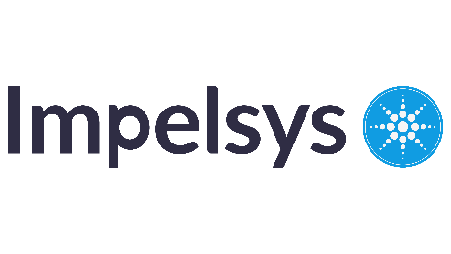
The goal is for accessibility to become a shared responsibility and organizational competency, rather than an outsourced remediation activity.

What are your accessibility highlights of the past 12 months?

Over the past 12 months, Impelsys has taken a systematic and scalable approach to strengthening accessibility across platforms, content, and industry awareness.
Scaling Accessibility Across Products and Content
We delivered more than 250 hours of WCAG-aligned digital learning, including a 100-hour program for disability-services professionals developed and deployed with full conformance. In parallel, we operationalized factory-level remediation across large volumes of PDF, Word, PowerPoint, Excel, and ePub3 content aligned to WCAG 2.1/2.2 AA, PDF/UA, and EPUB accessibility requirements.
Measured Improvement and Integrated Workflows
Through structured audits and remediation, accessibility scores across healthcare, education, publishing, and professional association platforms improved significantly, growing from baseline levels of 10–40 percent to between 70 and 95 percent. These outcomes were enabled by addressing keyboard navigation, focus management, semantic structures, ARIA issues, complex alt text, metadata alignment, and document tagging practices.
Standardized Methods and Quality Governance
To ensure consistency and repeatability, we established format-specific accessibility playbooks, WCAG checklists, and quality-assurance workflows supported by automated tools and assistive-technology testing. These practices use Microsoft Accessibility Checkers, Adobe Acrobat, PAC, NVDA, JAWS, and Narrator, and accessibility is now embedded earlier in editorial and production processes through accessible templates, author guidance, and staging-level review checkpoints.
AI-Assisted Acceleration and Human Validation
We accelerated delivery through AI-assisted workflows for accessibility issue detection and alt-text generation. These capabilities are combined with human-in-the-loop editorial review to ensure accurate and meaningful descriptions for academic, STEM, and educational content.
Capability Building and Internal Scale
We strengthened internal capacity by training and upskilling freshers and specialists in WCAG compliance, document accessibility, assistive technologies, and remediation practices. This created a sustainable talent engine for large-scale accessibility programs.
Thought Leadership and Ecosystem Awareness
We reinforced industry awareness through webinars on AI’s role in accessibility compliance and EAA readiness, and through publishing whitepapers such as “Making ePub Inclusive — The Role of ePub3”. These initiatives helped improve accessibility maturity not only within our organization but across the wider publishing community”. In addition, Impelsys has organized and hosted a series of industry-facing events including webinars, roundtables, and workshops that brought together accessibility practitioners, publishing leaders, and subject-matter experts. These forums enabled dialogue, knowledge sharing, and capability building, contributing to improved accessibility maturity not only within our organization but across the wider publishing ecosystem.
Impelsys further strengthened its expertise by onboarding Bill Kasdorf as an accessibility advisor, whose guidance has supported key client engagements and capability development initiatives over the past year.

What are you working towards in terms of accessibility in the coming year?

We are focused on elevating accessibility from remediation-driven to systemic, measurable, and scalable practice:
Born-accessible content creation
We are working with publishers to embed accessibility into templates, authoring tools, editorial processes, and platform capabilities. The intention is to ensure that new content in Word, PowerPoint, XML, EPUB, and PDF formats is created accessible from the start, reducing downstream remediation effort and improving overall quality.
Deeper automation and AI acceleration
Our priority is to expand the use of automation and artificial intelligence to increase consistency, speed, and scale. This includes using AI for structure detection such as headings, lists, and tables, alt text support, MathML generation, and pattern-based fixes. These capabilities will be supported by human oversight to maintain judgement and accuracy.
Formal certification and skills uplift
We are deepening testing expertise by enrolling key team members in the DHS Section 508 Trusted Tester program. This strengthens our capability to conduct accessibility evaluations and reporting aligned with recognized U.S. federal best practices and compliance expectations.
Accessibility for richer media formats
We are extending our services beyond document formats into audio, video, and interactive digital products. This includes support for transcripts, captions, descriptive audio, and accessible interaction patterns so that richer media experiences meet WCAG requirements and remain usable for people relying on assistive technologies.
Governance, measurement, and regulatory readiness
A key area of progress is helping publishers strengthen governance, metrics, and compliance readiness. This includes preparing for European Accessibility Act and Section 508 expectations through clear ownership models, dashboard-based tracking of coverage and defects, and documentation that supports audit and reporting requirements.
Shared capability development across the ecosystem
We continue to focus on capacity building by co-creating playbooks, training materials, and guidance with editorial, authoring, product, and vendor teams. The goal is for accessibility to become a shared responsibility and organizational competency, rather than an outsourced remediation activity.

TEXTBOX
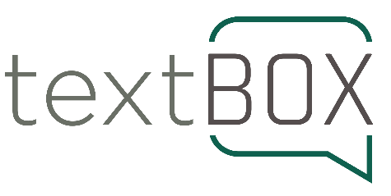

Being a small part of an industry-wide effort to make a difference for all readers.

What are your accessibility highlights of the past 12 months?

Highlights this year include working with a wide range of publishers and organisations to bring their content to life in preparation for the European Accessibility Act, and being a small part of an industry-wide effort to make a difference for all readers. Working in accessible publishing makes me smile as I get to work with so many smart, dedicated, and innovative people.
Highlights from this year included:
- Collaborating with Canongate to create image descriptions for their wonderful backlist titles.
- Working with Pottermore and Circular Software to create accessible versions of the new Pocket Potters series of titles exploring the world of Harry Potter.
- Providing the descriptions for the Getty Museum summer exhibition: Queer Lens: A History of Photography
- Exploring the world from my desk through writing descriptions for the Politikens Forlag travel book series, Turen går til.
- Collaborating with Microsoft to write descriptions for all the mathematical symbols in Microsoft Word (Math Autocorrect).
- Seeing more engagement with the ASPIRE project with the University of London attaining a 100% score for the quality of their accessibility statement.
- Running image description training sessions with a range of publishers such as Bloomsbury and the Lincoln Institute of Land Policy.
- Favourite books of the year: University College London: The Bloomsbury Campus by Amy Spencer and Colin Thom, The North Pole: The History of an Obsession by Erling Kagge, City Tech by Rob Walker, Buddhist Psychotherapy by Liang Tien, and Madly Deeply: The Alan Rickman Diaries.

What are you working towards in terms of accessibility in the coming year?

I’m looking forward to continuing to support publishers in their efforts to improve the user experience for all their readers. And I’ll be continuing to explore some intriguing developments in the AI space.

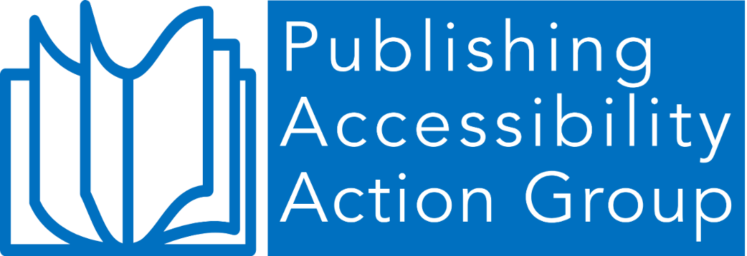

© Publishing Accessibility Action Group, 2025
First published 2025.

Attribution 4.0 International (CC BY 4.0).
This work is licensed under Creative Commons Attribution 4.0 International.

