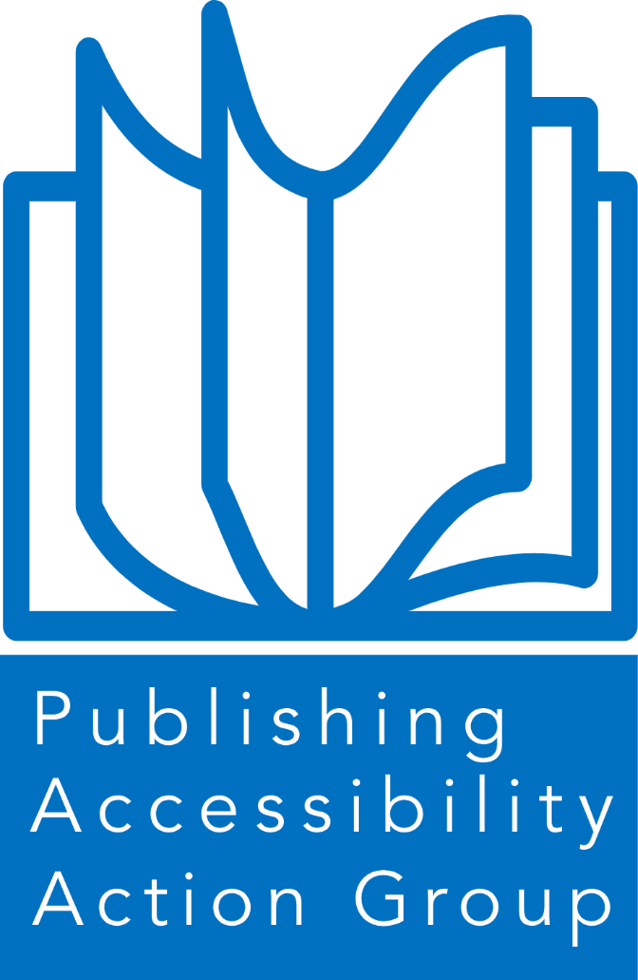

Publishing Accessibility Action group

ANNUAL REPORT 2023

## Contents

* Introduction to the PAAG annual report 2023
* PAAG Working Group members
* Acknowledgements
* Accessible Publishing Charter
  + Charter signatories
  + Charter allies
* PAAG Community
  + Website
  + LinkedIn
  + Meetings
  + Events
* Special theme: 2023 Member Survey
  + Westchester Publishing Services
  + McGraw Hill Education
  + Bookmachine
  + Glassboxx
  + Calibre Audio and Share the Vision
  + Penguin Random House
  + Elsevier
  + Taylor & Francis
  + Macmillan Learning

## Introduction from the PAAG chair

Welcome to the Publishing Accessibility Action Group annual report for 2023.

The Accessibility Action Group was founded in 2010 and has provided a forum for the publishing community to share insights and information around accessible publishing for over a decade. In the winter of 2022, the AAG was rebranded to the Publishing Accessibility Action Group (PAAG) and continues to offer support to the publishing community in implementing accessible publishing workflows and making content available to all.

The year has seen the launch of the [PAAG website](https://www.paag.uk/), the [PAAG LinkedIn group](https://www.linkedin.com/groups/12649969/), and, most importantly, the [PAAG accessible publishing charter](https://www.paag.uk/paag-charter-for-accessible-publishing/). We are delighted with the positive feedback and engagement from the publishing community, and it is especially encouraging to see 36 publishers and organisations committing to support the accessible publishing charter.

2023 welcomed the first [Accessible Publishing Conference](https://inclusivepublishing.org/blog/the-accessible-publishing-conference-a-first-for-the-uk/), hosted by the RNIB and the DAISY Consortium, and held at Google London. The year also saw numerous milestones in the accessible publishing community, including EPUB 3.3 becoming a [W3C recommendation](https://www.w3.org/publishing/epub3/), Bokförlaget Hegas AB winning the [ABC Publisher Excellence Award](https://www.accessiblebooksconsortium.org/w/news/2023/abc-international-excellence-awards-given-to-hegas-sweden-the-accessible-reading-materials-library-india-and-the-kalimat-foundation-uae), and the publication of IpEd’s comprehensive guide, [Books without barriers: a practical guide to inclusive publishing](https://www.iped-editors.org/resources-for-editors/books-without-barriers/).

2024 promises to be another exciting year in the development of accessible publishing due to the opportunities offered by artificial intelligence and the challenges of implementing the requirements of the forthcoming European Accessibility Act.

We hope you enjoy taking a look back over the year in this annual report. The PAAG and its charter members will continue to be at the forefront of accessible publishing in this coming year of change and we look forward to working with you all over the next 12 months.

Stacy Scott

*Chair of the Publishing Accessibility Action Group and Head of Accessibility at Taylor & Francis Group*

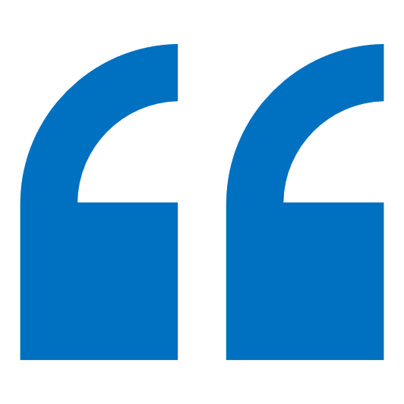The objective of the PAAG is to embed accessible practices throughout the publishing ecosystem to ensure that all content and reading systems are designed to be inclusive and user-focused.

## PAAG Working Group members 2023

The PAAG Working Group acts as a steering committee for PAAG. Led by Stacy Scott, Head of Accessibility at the Taylor & Francis Group, the working group gets together on a regular basis to discuss and implement initiatives. If you would like to join and contribute to the working group, please contact the chair via the PAAG LinkedIn Group or the PAAG mailing list.

In 2023, the PAAG working group members included:

* Stacy Scott, Taylor & Francis. Stacy is the Chair of the PAAG
* Sarah Hilderley, DAISY
* Richard Orme, DAISY
* Simon Mellins, Penguin Random House
* Rebecca Felton, Hachette
* Cecilia Rushton, Hachette
* Huw Alexander, textBOX

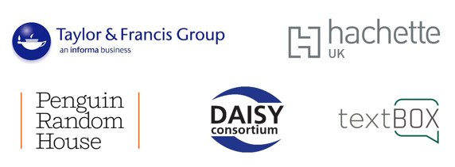

## Acknowledgements

The Publishing Accessible Action Group are very grateful for the continued support of the [Publishers Association](https://www.publishers.org.uk/) in hosting and coordinating our meetings, and the [UK Association for Accessible Formats](https://www.ukaaf.org/) for their generosity in supporting the creation and maintenance of the PAAG website.



## Accessible Publishing Charter

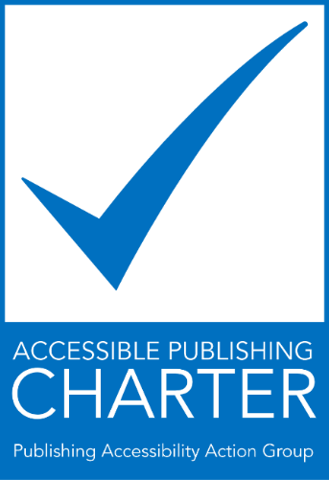

The Accessible Publishing Charter was launched in 2023 and encourages publishers and organisations to sign up to the charter and support the development of accessible publishing across the industry.

The growing availability of ebooks and other digital publications provides an unprecedented opportunity for persons with print disabilities to enjoy access to mainstream content at the same time, in the same format and at the same price as other readers. UK publishers and authors are eager to explore and develop the advantages that ebooks offer and, in so doing, reach more readers. Ensuring that ebooks are fully accessible, however, will only happen if publishers, authors, developers, platforms, and other stakeholders focus on this issue at a practical level.

Our objective is to make our content accessible to all and to aid others in this endeavour.

The signatories to the Accessible Publishing Charter commit to the following 10 goals

1. Raising awareness among, and providing training for, relevant staff.
2. Nominating a company “accessibility champion” who can bring together key stakeholders to discuss potential accessibility improvements and act as a liaison for all accessibility information.
3. Publishing our accessibility policy on our website, including our commitment to this charter.
4. Designating and publicising a point of contact in our organisation to assist persons with disabilities to access alternate formats of our content.
5. Partnering with national and international organisations that provide support for the availability of publications in accessible formats.
6. Incorporating appropriate accessibility features within our digital publications and platforms, according to the web content accessibility guidelines and other appropriate accessibility standards.
7. Advocating for accessibility standards and collaboration throughout the publishing supply chain from author to reader.
8. Utilising the accessibility metadata opportunities available to aid with the discovery of accessible content.
9. Testing and validating content to ensure it is usable by people with print disabilities. Ideally this would include testing by persons with lived experience.
10. Monitoring our progress in this area and regularly assessing the accessibility of our digital publications and platforms.



### Charter signatories

14 publishers have signed the Accessible Publishing Charter in 2023:

* 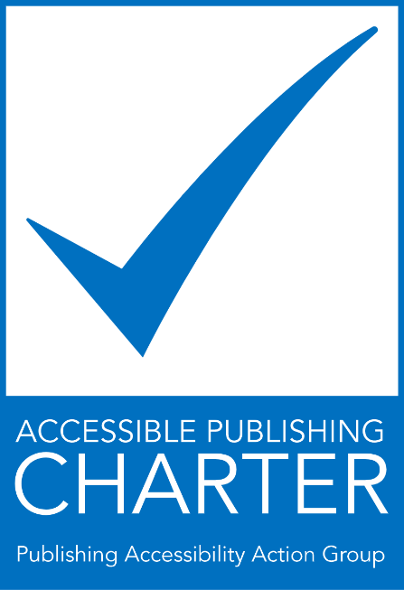[Bloomsbury](https://www.bloomsbury.com/uk/)
* [Cambridge University Press & Assessment](https://www.cambridge.org/)
* [Edward Elgar Publishing](https://www.e-elgar.com/)
* [Elsevier](https://www.elsevier.com/en-gb)
* [Hachette UK](https://www.hachette.co.uk/)
* [HarperCollins Publishers](https://harpercollins.co.uk/)
* [Kogan Page](https://www.koganpage.com/)
* [McGraw Hill Education](https://www.mheducation.com/)
* [Macmillan Learning](https://www.macmillanlearning.com/college/us/our-story/accessibility)
* [Pan Macmillan](https://www.panmacmillan.com/)
* [Penguin Random House](https://www.penguinrandomhouse.com/)
* [Pottermore Publishing](https://www.pottermorepublishing.com/)
* [Springer Nature](https://www.springernature.com/gp)
* [Taylor & Francis](https://taylorandfrancis.com/)

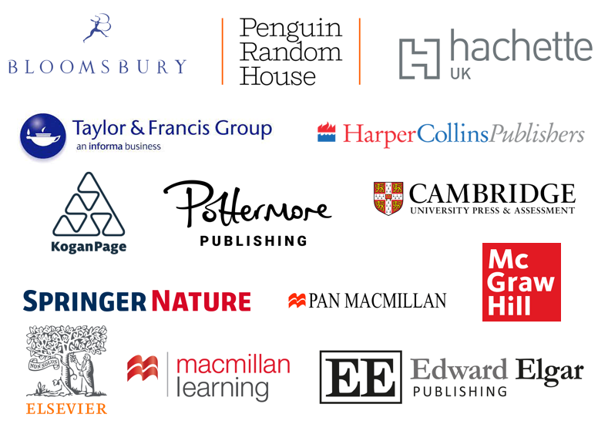

### Charter allies

24 organisations have signed the Accessible Publishing Charter as allies in 2023:

* [BookMachine](https://bookmachine.org/)
* [Calibre Audio](https://www.calibreaudio.org.uk/)
* [Cenfor International](https://www.cenfor.net/)
* 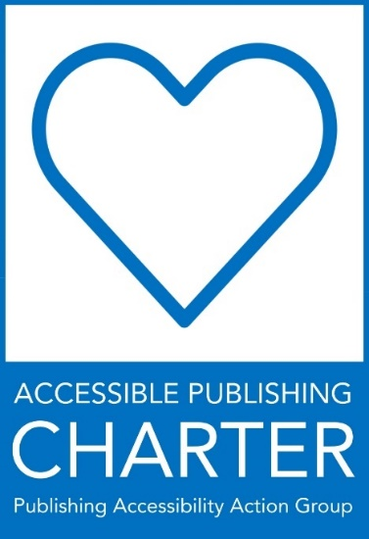[codemantra](https://codemantra.com/)
* [Connect Design Solutions](https://connecttodesign.co.uk/)
* [Copyright Licensing Agency](https://cla.co.uk/)
* [DAISY Consortium](https://daisy.org/)
* [EDItEUR](https://www.editeur.org/)
* [Flexedo](https://www.flexedo.com/)
* [Fondazione LIA](https://www.fondazionelia.org/en/)
* [Glassboxx](https://glassboxx.com/)
* [Haremi](https://www.haremi.co.uk/index.php)
* [Ingram Content Group](https://www.ingramcontent.com/)
* [Inspired Search & Selection](https://www.inspiredselection.com/)
* [ISI](https://www.isicrunch.com/)
* [Just Content](https://www.justcontent.co.uk/)
* [Refreshing Publishing](https://www.refreshingpublishing.com/)
* [Royal National Institute of Blind People (RNIB)](https://www.rnib.org.uk/)
* [RNIB Bookshare](https://www.rnibbookshare.org/cms/)
* [Share the Vision](https://readingsight.org.uk/)
* [textBOX](https://www.textboxdigital.com/)
* [UK Association for Accessible Formats (UKAAF)](https://www.ukaaf.org/)
* [Westchester Education UK and International](https://westchestereducation.co.uk/)
* [Westchester Publishing Services UK](https://westchesterpublishingservices.co.uk/)

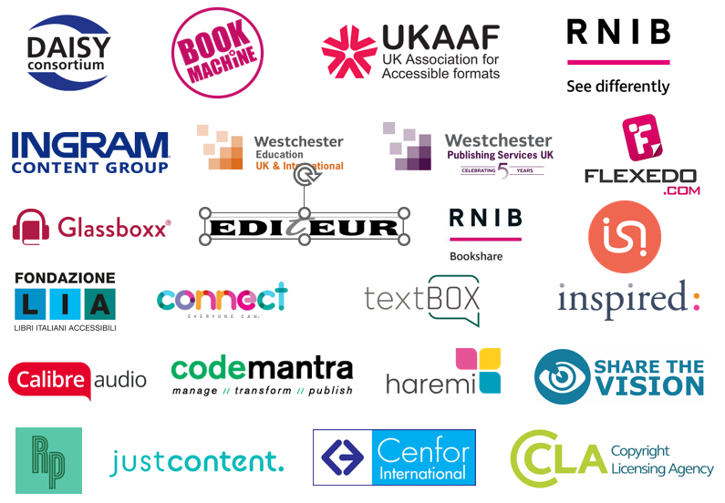

## Community

The PAAG community has developed in 2023 to include a newly launched website, a LinkedIn group with over 220 members, bi-monthly meetings, a new mailing list, and attendance at a range of industry events.

### Website



The PAAG website launched in late 2022 with the kind support of the UK Association for Accessible Formats ([UKAAF](https://www.ukaaf.org/)).

The website explores the business case for accessible publishing and provides the answers to frequently asked questions about accessible publishing. The resources pages cover a wide range of topics including:

* Accessibility accreditation: including the Accessible Books Consortium, Global Accessible Accreditation from Benetech, and the ASPIRE accessibility statement review service.
* Accessibility organizations + advocates: a list of national and international organisations working in the accessibility field.
* Accessibility statements + VPATS: creating user-focused accessibility statements and VPATs.
* Creation + provision of accessible content: including accessible content repositories, writing image descriptions, and creating accessible assessment content.
* Formats:
* Metadata: information about metadata including ONIX and Thema.
* Models + language: including the accessible maturity model and SCULPT.
* Regulations + web guidelines: including WCAG, PSBAR, EAA, Section 508, and Marrakesh.
* Testing + tools: guides for accessibility tests and useful tools to help with the process including DAISY Ace.
* Training + learning: a selection of resources for training purposes and learning more about accessible publishing including webinars and courses.

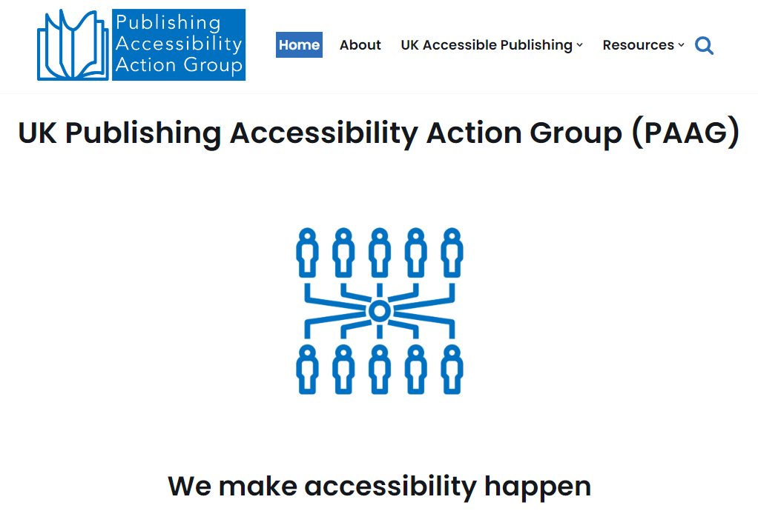

The PAAG website has been viewed by visitors from 71 countries around the world and illustrating the vibrant interest in developing accessible publishing programmes across the world.

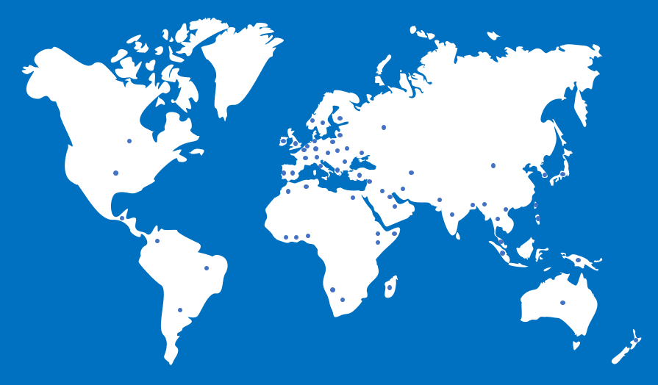

### LinkedIn

The PAAG LinkedIn group was launched in early 2023 and now includes over 220 members. The group acts as a forum for sharing news and information, and for discussing and implementing accessible publishing. The group contains a wide variety of members from across the publishing community, including an international range of publishers, ebook platforms, technology vendors, academic institutions, and accessibility advocates.

The [LinkedIn group](https://www.linkedin.com/groups/12649969/) welcomes anyone interested in accessible publishing to join the group.

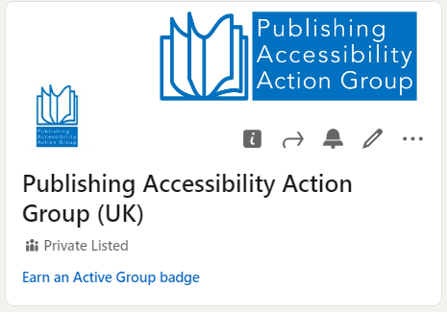

### Meetings

5 PAAG meetings have taken place in 2023. The agendas from each meeting are listed below and outline the range of topics addressed this year.

**26 January**

* Guest speaker: Bill Kasdorf.
* London Book Fair accessibility seminar.
* Inclusive Publishing event with RNIB.
* PAAG Charter update.
* Open Q & A.

**30 March**

* London Book Fair.
* PAAG meet-up.
* Guest speaker: Accessible data visualisation with Daniel Hajas.
* Guest speaker: SIDD: the Simple Image Description Database with Ken Jones.
* DAISY technical conference update.
* Adobe InDesign update.
* European Accessibility Act guidance.
* PAAG Charter update.

**29 June**

* PAAG working group.
* PAAG discussion list.
* AI update and discussion.
* Ebooks audio assets.
* DAISY conference update.
* Adobe InDesign update.

**28 September**

* AI update.
* Alt text update.
* European Accessibility Act update.
* Accessible Publishing Conference.
* Adobe InDesign update.
* PAAG Charter update.

**30 November**

* Publishers Association A legal perspectives on the European Accessibility Act .
* Reflections on the London Accessibility Publishing Conference.
* Frankfurt Book Fair accessibility workshop.
* Editeur Supply Chain Seminar.
* London Book Fair 2024 planning and the Accessibility Boot Camp concept.
* Update on Adobe InDesign.
* PAAG annual report.

### Events



PAAG members organised and participated in a range of events and conferences during 2023 including the following:

* **London Book Fair (April)**

The London Book Fair hosted the seminar, Accessibility: Charting the Waters. Stacy Scott chaired the seminar and speakers included Laura Brady, Richard Orme form DAISY, Simon Mellins from Penguin Random House, and Martin Klopstock from Kogan Page. Read more about the [Charting the Waters session](https://inclusivepublishing.org/blog/accessibility-charting-the-waters/) on the Inclusive Publishing website.

* **IPG Spring conference+ (May)**

Richard Orme from DAISY and Julie Willis from Westchester Publishing Services UK presented the session, Rising To The Accessibility Challenge which provided an overview of the European Accessibility Act. Read more about the [Rising to the Accessibility Challenge session](https://www.inspiredselection.com/insights/industry-news/ipg-spring-conference-rising-accessibility-challenge) on the Inspired Selection website.

* **Frankfurt Book Fair (October)**

An accessibility networking event featured a keynote by LIA’s Cristina Mussinelli.

* **Accessible Publishing Conference (November)**

Hosted by Richard Orme with guest speakers including Stacy Scott, Simon Mellins, Romain Deltour, Rick Johnson, Michael Johnson, Laura Brady, and Cristina Mussinelli. Explore an [overview of the Accessible Publishing conference](https://inclusivepublishing.org/blog/the-accessible-publishing-conference-a-first-for-the-uk/) on the Inclusive Publishing website.

* **Accessibility in Scholarly Publishing: ALPSP Webinar (November)**

This webinar focused on the importance of inclusivity in publishing, specifically through the application of standards, to ensure accessibility of research content. Speakers included Stacy Scott, Mark McCallum, and Glenda Sims.

## Special theme: PAAG Charter member survey 2023

### Introduction

To mark the first anniversary of the launch of the Accessible Publishing Charter, we asked our charter signatories to reflect on their year and the 12 months ahead. We asked the following 2 questions:

1. What are your accessibility highlights of the past 12 months?
2. What are you working towards in terms of accessibility in the coming year?

The following pages include the responses from PAAG charter members and provide insights into their achievements over the past 12 months and the future accessibility plans of key players in the publishing industry. Explore the responses from Elsevier, Taylor & Francis, Penguin Random House, Macmillan Learning, McGraw Hill, Westchester Publishing Services, Bookmachine, Glassboxx, Share the Vision, and Fondazione LIA.

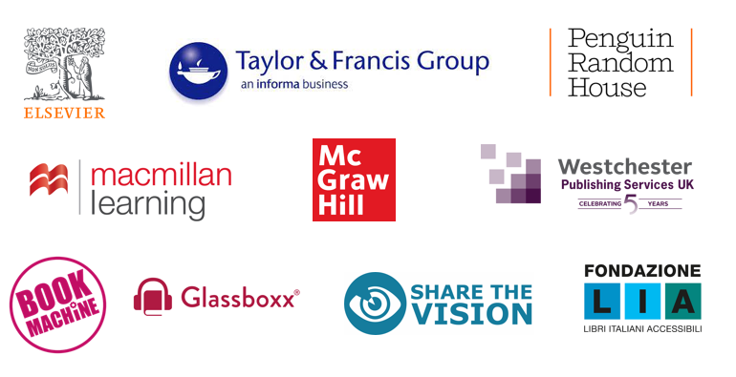

## Westchester Publishing Services



We are performing an accessibility audit of our digital presence. This includes all our websites, email formatting, marketing emails and marketing content.

### What are your accessibility highlights of the past 12 months?

* Producing a podcast on accessibility and the EAA for the Independent Publishers’ Guild.
* Taking part in a webinar with Richard Orme (DAISY) for Independent Publishers’ Guild.
* Showcasing our Benetech-approved accessibility credentials for creating accessible digital files to UK university presses.
* Reviewing code and process for fixed-layout accessible files in response to EPUB 3.3 and EPUB accessibility 1.1 specs.

### What are you working toward in terms of accessibility in the coming year?

* We are performing an accessibility audit of our digital presence. This includes all our websites, email formatting, marketing emails and marketing content.
* We will continue to monitor new accessibility standards and respond to them.



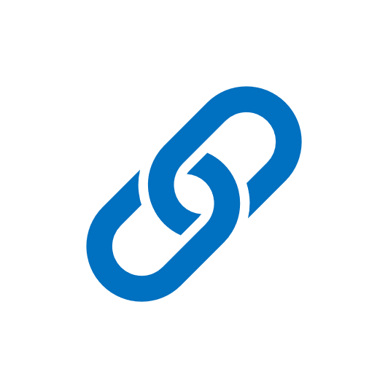

Learn more about their work on the [Westchester Publishing Services website](https://westchesterpublishingservices.co.uk/).

## McGraw Hill Education



We have extended our accessibility awareness and training to every internal department in preparation for the European Accessibility Act.

### What are your accessibility highlights of the past 12 months?

* We have extended our accessibility awareness and training to every internal department in preparation for the European Accessibility Act.
* We have updated processes to produce ‘born accessible’ EPUBs and are excited to be on track to start publishing these before the end of this year.
* We are starting to add accessibility metadata to inform on accessibility features and hazards.

### What are you working toward in terms of accessibility in the coming year?

* Updating internal systems to streamline provision of metadata for Schema and ONIX.
* Improving end-to-end accessible workflows.
* Improving the accessibility of our ecommerce sites to meet European Accessibility Act requirements.

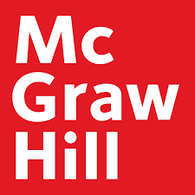



Learn more about [McGraw Hill Education’s accessibility policy](https://www.mheducation.co.uk/about/accessibility-policy) on their website.

## Bookmachine



We are working towards creating company standards around accessibility for the work we do for our clients in the books and education marketing space, to standardise the accessibility of the content.

### What are your accessibility highlights of the past 12 months?

Over the past 12 months, we have planned and run a range of in-person events in London, Oxford, and Edinburgh, all with a digital ticket option. This consists of a professional, fully edited, and subtitled recording of the live event for ticket holders to watch when and where suits them. After the success of digital ticket sales over the past year, displaying the importance of this option for our audience, we are committed to not go back to only in-person, London-centric venues, and to offer digital or recorded events with access front-of-mind. For our in-person events, we have selected venues with access in mind - wide doorways, lift access, seating and so on. We have referred to the excellence [Inklusion Guide](https://www.inklusionguide.org/) for planning our in-person events.

### What are you working toward in terms of accessibility in the coming year?

We are striving to improve and grow our annual range of events and resources, so they are as accessible for as many people as possible - whether that is bringing them to geographical locations outside of London or the Southeast of England, providing digital events, audio content and written blog posts (with image captions/alt text). We are also working towards creating company standards around accessibility for the work we do for our clients in the books and education marketing space, to standardise the accessibility of the content across the board. We are also hoping to highlight accessibility within our 2024 programme, working with our Production Editorial Board Member, Ken Jones, on providing content for our audience of publishing professionals.

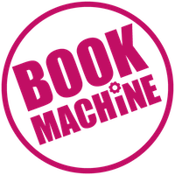



Learn more about their work at the [Bookmachine website](https://bookmachine.org/).

## Glassboxx



In the coming year, we will be continuing to expand the features and functionality of our apps and solutions to accommodate every reader and every sector as fully as possible.

### What are your accessibility highlights of the past 12 months?

* In terms of accessibility, we have continued to make this a key focus of the Glassboxx apps, with features such as background colour changes, font size and font face changes, highlighting, and book syncing across platforms.
* Our design team works closely with our developers and marketing to ensure that all design is accessibility friendly, and this extends across our print materials also, with all Glassboxx print materials optimised for accessibility with an emphasis on colour and contrast for example.
* In other areas we have updated our company website to include alt text across all images and have implemented alt text across all social media where possible.

### What are you working toward in terms of accessibility in the coming year?

* In the coming year, we will be continuing to expand the features and functionality of our apps and solutions to accommodate every reader and every sector as fully as possible. Glassboxx is designed with UX in mind, and we consider accessibility to be the most crucial aspect of this - our aim is for our solutions to be as intuitive as possible for end users.





Learn more about their work at the [Glassboxx website](https://glassboxx.com/).

## Calibre Audio / Share the Vision



We are launching a free Resource Pack for people working in libraries across the UK to help them help readers with a vision or print impairment.

### What are your accessibility highlights of the past 12 months?

Share the Vision champions accessible libraries and reading formats and our highlight from the last 12 months was launching a [free Resource Pack](https://readingsight.org.uk/resource-pack/) for people working in libraries across the UK to help them help readers with a vision or print impairment.

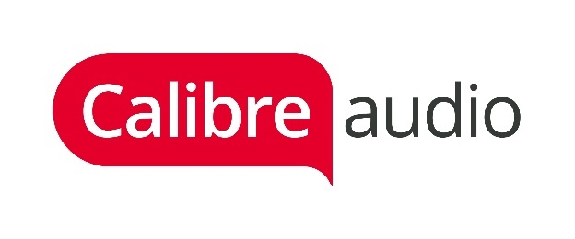





Learn more about their work at the [Calibre Audio](https://www.calibreaudio.org.uk/) and [Share the Vision](https://readingsight.org.uk/) websites.

## Fondazione LIA



Fondazione LIA broadened its initiatives…encompassing training and consultancy services, accessibility audits for publications, websites, and platforms, as well as research and development.

### What are your accessibility highlights of the past 12 months?

In 2023, Fondazione LIA broadened its initiatives both within Italy and globally, encompassing training and consultancy services, accessibility audits for publications, websites, and platforms, as well as R&D. A particular emphasis was placed on the introduction of an international Quality Assurance program that mirrors the title-by-title methodology adopted in the Italian market, with the objective of confirming the adherence to international EPUB accessibility standards for each file.

To promote accessibility and inclusion over the year LIA organized many awareness-raising initiatives and professional events as an Accessibility Camp during [Readmagine](https://readmagine.org/) in Madrid, bringing together publishing professionals and experts in digital accessibility, Readings in the DarkÒ within the European project [Aldus UP](http://www.aldusnet.eu/).

### What are you working toward in terms of accessibility in the coming year?

There are still numerous aspects to address in the establishment of a globally accessible publishing ecosystem, such as displaying accessibility metadata on all platforms, defining accessibility workflows, and examining the impact of AI on creating accessible content, to name a few.

In a more practical context, LIA plans to initiate a new European project, APACE (Accelerating Publishing Accessibility through Collaboration in Europe), in 2024. This project aims to facilitate a two-way conversation between publishers and specialized organizations involved in producing accessible publications. By engaging stakeholders from both communities, APACE seeks to drive innovation in the production and distribution of Born Accessible publications, enhance efficiency to boost the number of accessible e-books, and position accessibility as a strategic asset in Europe.

2024 will also see the last activities of the [ABELab](https://www.abelab.eu/), a collaborative project aiming to provide publisher with correct information about options and costs for remediation to make backlist ebooks accessible.

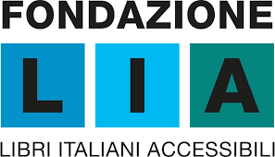

## Penguin Random House



We made amazing progress with a key supplier in developing our image description workflow, and the image descriptions themselves.

### What are your accessibility highlights of the past 12 months?

* We made amazing progress with a key supplier in developing our image description workflow, and the image descriptions themselves. We’ve been developing a style guide as we go which is already making things far easier.
* Seeing the industry come alive, and conversations we’ve been having for years suddenly gain more traction and interested voices than ever.

### What are you working toward in terms of accessibility in the coming year?

* Further development of image descriptions, with plans to get them in all frontlist soon.
* Continuing to test files and templates on real accessible reading software to ensure a great user experience across access modes.

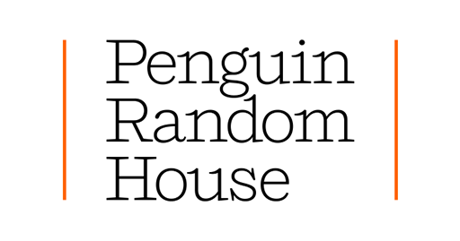



Learn more about their work at the [Penguin Random House website](https://www.penguin.co.uk/).

## Elsevier



Elsevier’s ScienceDirect achieved the WebAIM Million #1 ranking of accessible home pages.

### What are your accessibility highlights of the past 12 months?

* Elsevier’s ScienceDirect achieved the [WebAIM Million #1 ranking](https://webaim.org/projects/million/lookup?homepage=sciencedirect.com) of accessible home pages.
* Achieved [Benetech’s Globally Certified Accessible](https://publishingperspectives.com/2023/07/the-netherlands-elsevier-gains-benetech-accreditation/) for our EPUB books.
* We released our first set of fully tagged PDF journal articles.
* Started our 6th year of belting training program. We have had over 340 people complete Deque’s Web Accessibility Training courses.
* Began a regular screen reader user testing partnership around [SciVal](https://www.scival.com/landing), our researcher performance analytics tool.
* Expanded our program to improve digital accessibility for employee tools and content.
* Created a new set of 7 user personas around people with disabilities who use our products.

### What are you working toward in terms of accessibility in the coming year?

* Optimizing alt text creation for images in books and journals.
* Streamlining our service for providing eBook accommodations to disability services offices.
* Releasing fully tagged PDF books.
* Updating our policy and product accessibility guidance to WCAG 2.2.
* Alt-text descriptions at scale for frontlist books.
* Accessibility metadata for books in line with EAA requirements.
* aim to have identified and put into action, a robust strategy for improving the accessibility of video content and ancillary components contained within some eBook content.

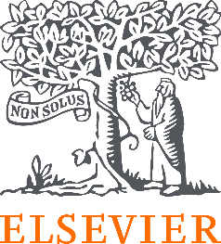



Learn more about their work at the [Elsevier website](https://www.elsevier.com/en-gb/about/accessibility).

## Taylor & Francis



We are planning to see an increase in new frontlist titles published with alt text and long descriptions and should surpass 6,000 titles next year. We will also begin generating alt text for some of our deep backlist titles.

### What are your accessibility highlights of the past 12 months?

**Books and journals:**

* Taylor & Francis has now published more than 3,800 titles with alt text!
* We have also remediated more than 45,000 EPUB2 files into the more accessible EPUB3 file format.
* We converted more than 1,200 deep backlist titles into eBook formats, where only print was available. This will help supply more accessible content to customers and means we have close to 98% of entire back catalogue available in eBook format, where rights allow.
* Recertified our GCA accreditation.
* Updated our internal systems to match EPUB 3.3 and EPUB Accessibility 1.1 specifications.
* Built on our extensive work with authors for our author written alt text program.

**Platforms:**

* Completed a comprehensive ‘identify and fix’ accessibility audit on our key books and journals platforms, as well as some ancillary sites and their content components.
* Updated our existing VPATs as part of their annual review. Added new VPATs and Accessibility Statements for new products.

### What are you working toward in terms of accessibility in the coming year?

* Taylor & Francis continue to focus on the volume of titles we publish which contain alt text. We are planning to see an increase in new frontlist titles published with alt text and long descriptions and should surpass 6,000 titles next year. We will also begin generating alt text for some of our deep backlist titles.
* By the end of 2023, we plan to begin sending full accessibility metadata out for all titles within our ONIX feeds.
* By the end of 2024 we plan to have completed full accessibility audits on both existing and upcoming sites/products.
* We aim to have identified and put into action, a robust strategy for improving the accessibility of video content and ancillary components contained within some eBook content.
* Updating our customer service process in Salesforce, to ensure customers get where they need to go, as quickly as possible.
* Building partnerships to use more comprehensive testing tools for platforms going forward.
* Continuing to support our authors in providing alt text for both books and journals.





Learn more about their work at the [Taylor & Francis website](https://taylorandfrancis.com/about/corporate-responsibility/accessibility-at-taylor-francis/).

## Macmillan Learning



In 2024, we will expand our customer outreach programs to get even better feedback from instructors and students about their experiences with disability in the classroom.

### What are your accessibility highlights of the past 12 months?

Macmillan Learning was proud to sign the Publishing Accessibility Action Group Charter this year as well as become a member of the associated working group. The objectives of PAAG align with our own accessibility guiding principles, which we introduced this year:

* **Champion Equal Access**: Commit to providing all users, regardless of abilities, with equal opportunities to learn.
* **Elevate Teaching & Learning Experiences**: Craft user-friendly and standards compliant designs that uplift and enrich the lives of all users.
* **Innovate with Purpose**: Embrace accessibility challenges as inspiration to develop groundbreaking, inclusive solutions.
* **Encourage Lifelong Learning**: Cultivate a culture of continuous growth, fostering a deep understanding of accessibility and disability inclusion that translates into transformative solutions.
* **Nurture Collaboration**: Foster cooperation among team members and users with disabilities to address diverse needs throughout development of our products and services.

We shared these principles with the entire company and also featured it on our company’s blog for the world to see. While our principles are new this year, our passion for accessibility, inclusion and equity in education is not. For the fourth consecutive year Macmillan Learning was recognized as having Global Certified Accessible ebooks. This year also marks the third consecutive year that we were named a [Top Employer for People with Disabilities](https://disabilityin.org/what-we-do/disability-equality-index/2023companies/) from Disability:In.

We continue to invest in our people, products and culture in a way that supports employees and learners of all abilities. To support our people and an inclusive culture, the Macmillan Learning employee resource group for people and allies of people with disabilities continued with their goal to educate and raise awareness with more than 20 blog posts and five virtual events. Our product and engineering teams dedicated significant effort to our Virtual Lab Simulations, receiving positive reviews from customers as well as peers at Accessing Higher Ground. These are just some of the many achievements that mark Macmillan Learning’s continued investment of our employees to make not only our products accessible but to ensure we are living our accessibility best practices in house as well.

### What are you working toward in terms of accessibility in the coming year?

In our continued focus on living our accessibility principles, Macmillan Learning has dedicated time and resources to the ongoing upskilling of our workforce in 2024, from a technology-focused training and remediation event to a broad introduction to accessibility in a self-paced environment for all employees. Additionally, the accessibility team in partnership with the employee resource group will continue monthly training sessions, presentations, and meetings to discuss accessibility in both our workplace and our products.

Our product and engineering teams have already begun working on a “shift left” plan that will reduce accessibility issues in our products that go to market. This program will expand based on where we see additional opportunities from the aforementioned upskilling event.

Also in 2024, we will expand our customer outreach programs to get even better feedback from instructors and students about their experiences with disability in the classroom. The outreach includes the relaunch of the Macmillan Learning Accessibility Advisory Board, which consists of higher education accessibility professionals that meet quarterly to discuss accessibility issues and of course, wins. With their guidance, we hope to learn about how we can better support our customers, disability services offices and the students that use our course materials.

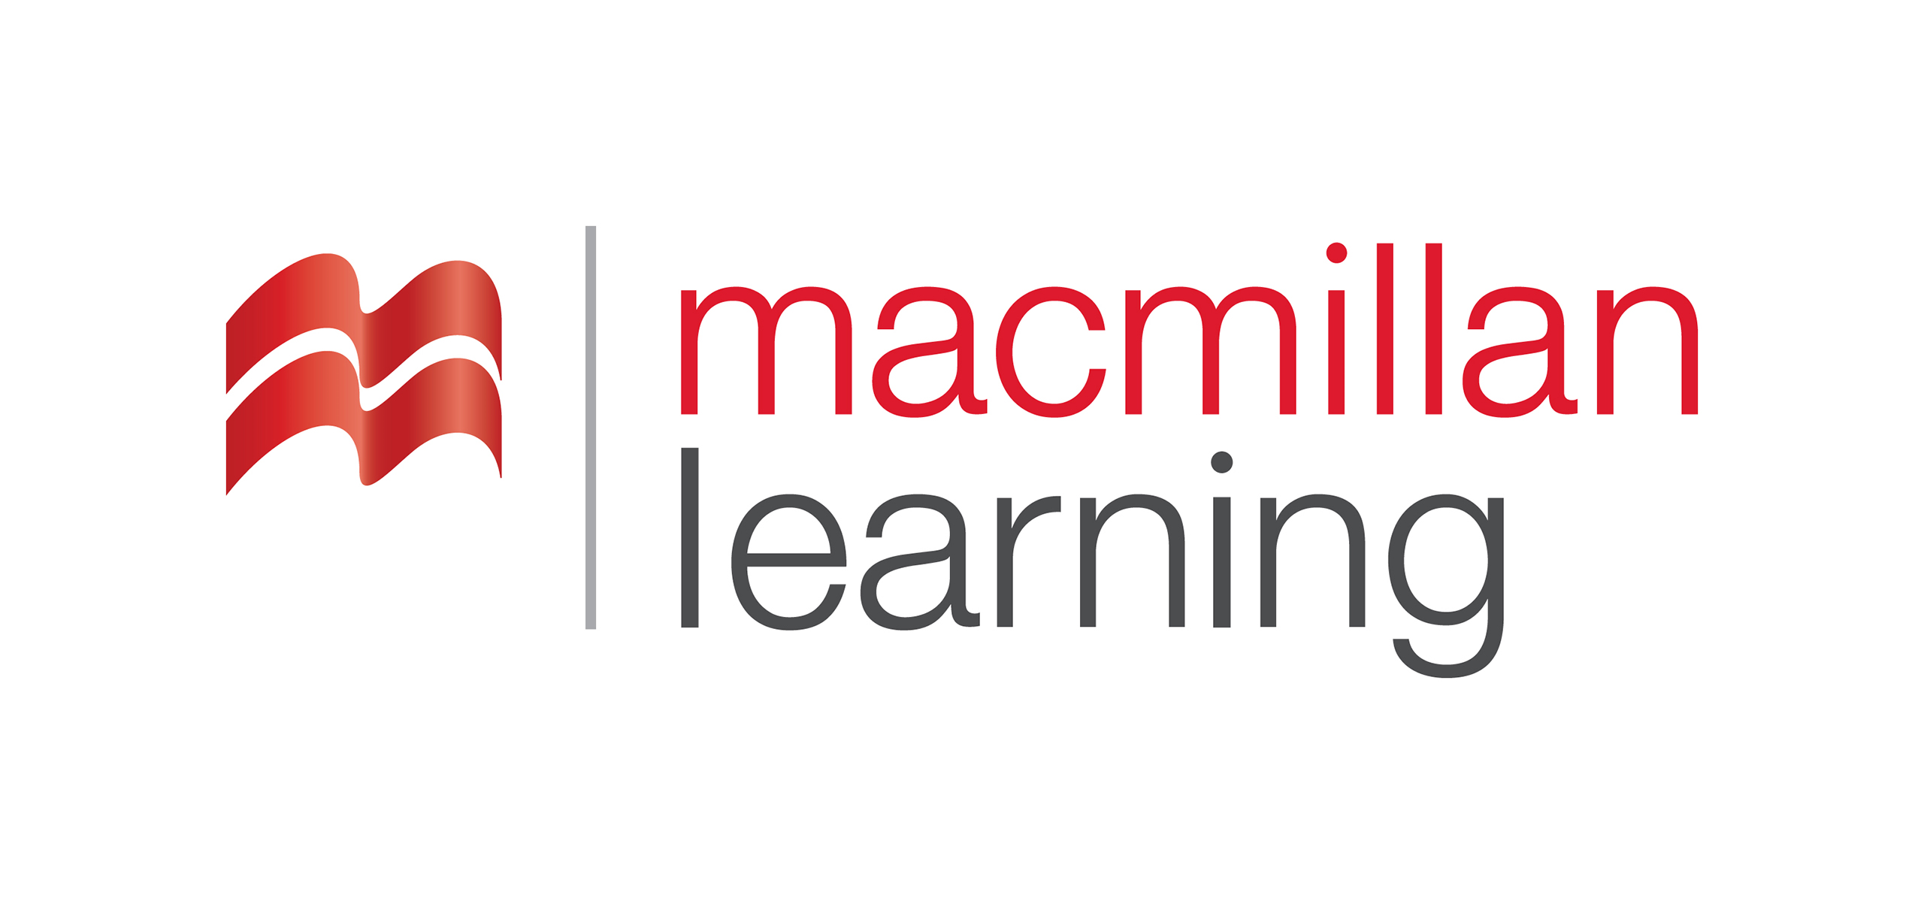



Learn more about their accessibility work on the [Macmillan Learning website](https://www.macmillanlearning.com/college/us/our-story/accessibility).

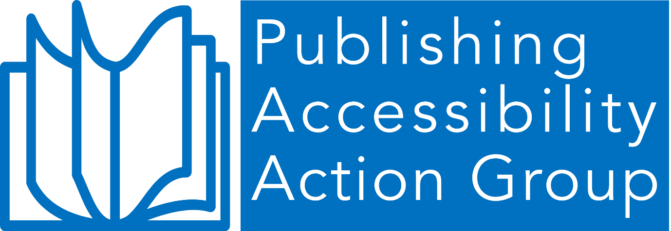

© Publishing Accessibility Action Group, 2024

First published 2024.

 

Attribution 4.0 International (CC BY 4.0).

This work is licensed under Creative Commons Attribution 4.0 International.